**LAB REPORT Observing Linux Behavior**

CSCI411 Lab

# **Submission Requirements**

Submit to Blackboard

* This report
* Source file built in Part B

**Introduction**

The Linux kernel is a collection of data structure instances (*kernel variables)* and functions. The collective kernel variables define the kernel’s perspective of the state of the entire computer system. Each externally invoked function – a system call or an IRQ (interrupt request) – provides a prescribed service and causes the system state to be changed by having the kernel code changed its kernel variables. If you could inspect the kernel variables, then you could infer the state of the entire computer system.

This report demonstrates your knowledge of the observations obtained about kernel and its status.

**Lab Environment**

Describe the /proc directory

The /proc directory is a directory used to store system information.

Describe/explain why the /proc directory is often referred to as a *virtual file system.* You will have to define what a virtual file system is, too.

A virtual file system provides common interface abstraction for file systems. /proc directory contains system calls, which are contained in the system call interface, but because we are able to access it in the file system, it is considered a virtual file system.

**Interactive Observation Questions**

Answer the following questions about the Linux machine that you used to do these exercises. Include the program/command or other method you used to obtain the information. For each, give a brief explanation the information provided.

1. What is the system hostname?

Abernathy

* + What commands did you use to get this information?

hostname

* + Give a brief explanation of the information provided.

Displays the name of the current machine that is hosting my linux session

1. **What version of the Linux kernel is being used**

4.4.0-101-generic GNU/Linux

* + What commands did you use to get this information?

Uname -or

1. **How many processors are on this system?**

2

* + What commands did you use to get this information?

Nproc

1. **For each processor: list the CPU Vendor, model number and model name.**

CPU Vendor: GenuineIntel

Model #: 45

Model Name: Intel(R) Xeon(R) CPU E5-2630 v3 @ 2.40GHz

* + What commands did you use to get this information?

Cat cpuinfo in /proc directory

1. **How much memory is on the machine? How much if currently free?**

MemTotal: 16432752 kB

MemFree: 1308588 kB

* + What commands did you use to get this information?

Cat meminfo in /proc directory

1. **How long in seconds has the system been up (since last boot)?**

4431569.93

* + What commands did you use to get this information?

Cat uptime in /proc directory

* + Provide a screen shot of your output

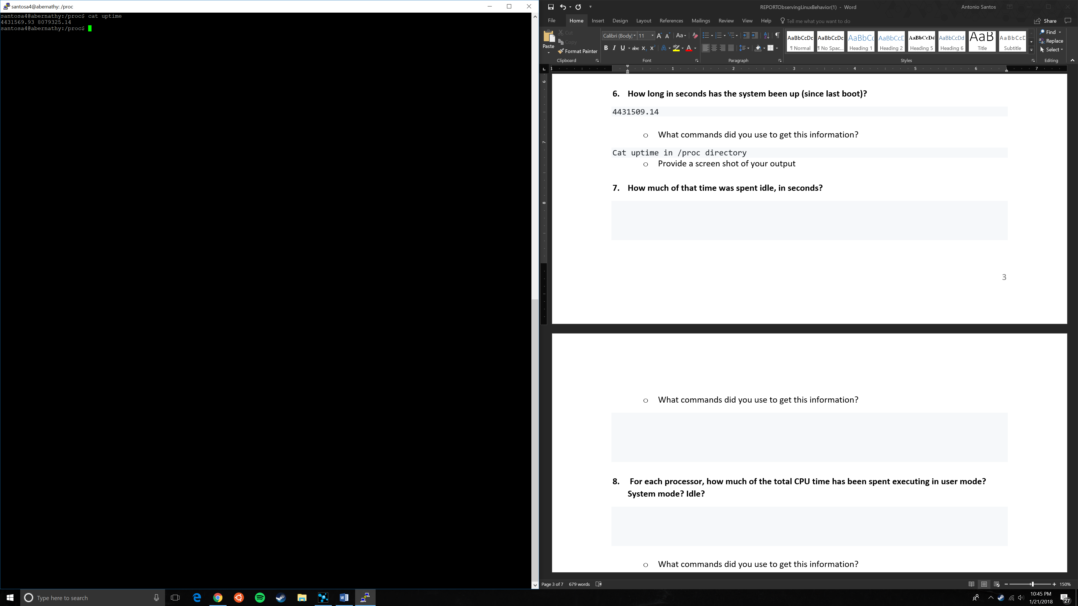

1. **How much of that time was spent idle, in seconds?**

8079325.14

* + What commands did you use to get this information?

Cat uptime in /proc directory

1. **For each processor, how much of the total CPU time has been spent executing in user mode? System mode? Idle?**

Us: .2%

Sy: .3%

Id: 99.5%

* + What commands did you use to get this information?

top

* + Provide a screen shot of your output

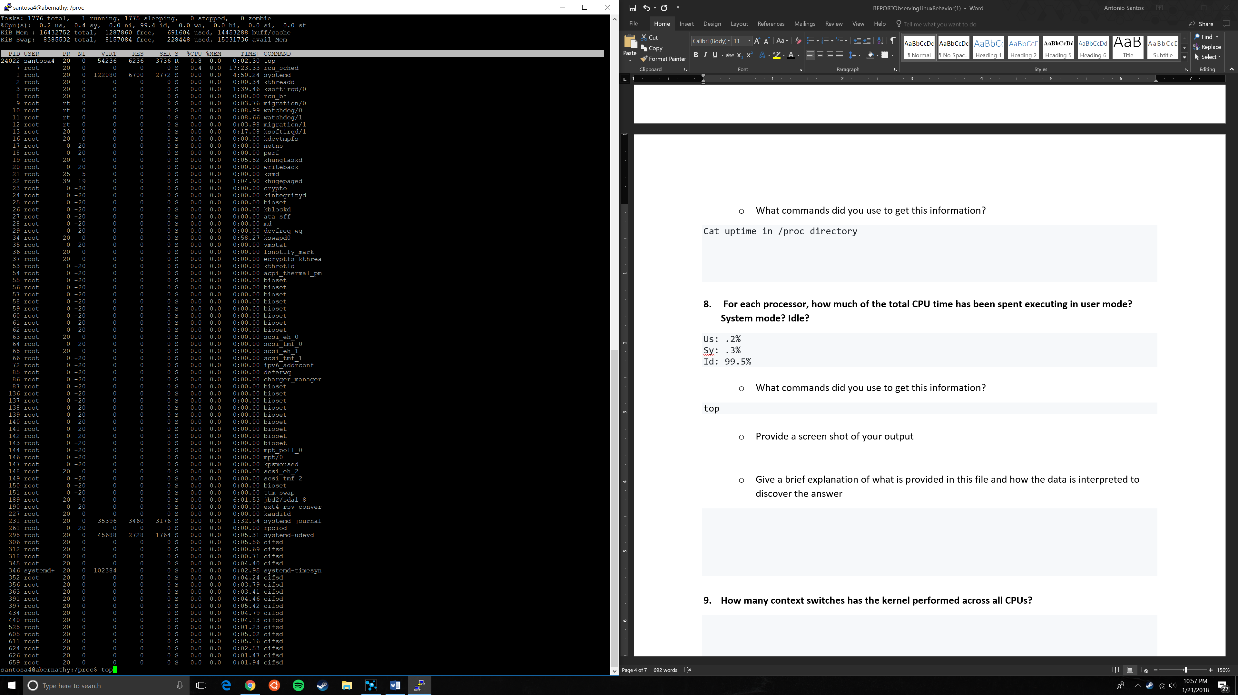

* + Give a brief explanation of what is provided in this file and how the data is interpreted to discover the answer

All processes are shown and at the top of the screen, a layout of how the CPU is being utilized is given.

1. **How many context switches has the kernel performed across all CPUs?**

3367907966

* + What commands did you use to get this information?

cat /proc/stat | grep "ctxt"

* + Provide a screen shot of your output
  + 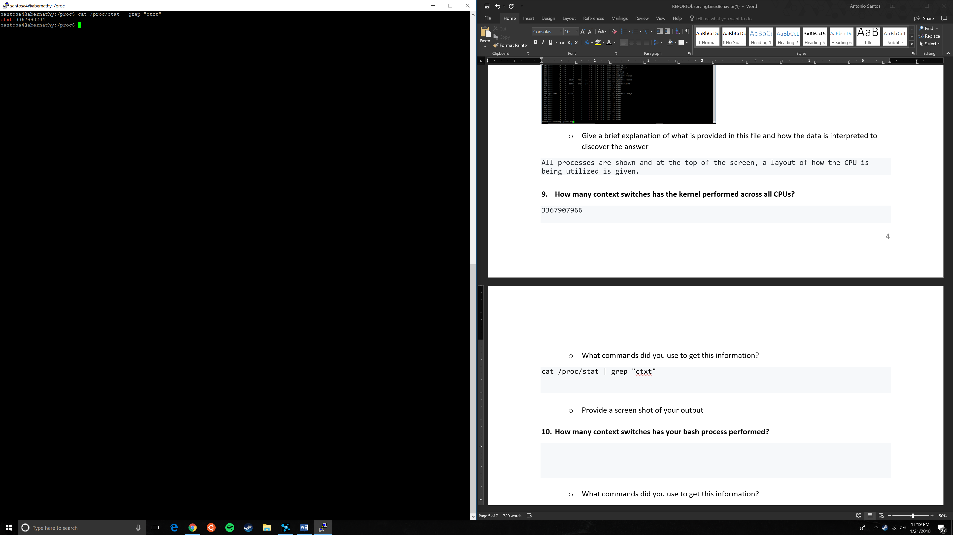

1. **How many context switches has your bash process performed?**

Voluntary: 659

Nonvoluntary: 125

* + What commands did you use to get this information?

Ps to see what the pid is for bash

Cat /proc/<pid>/status

* + 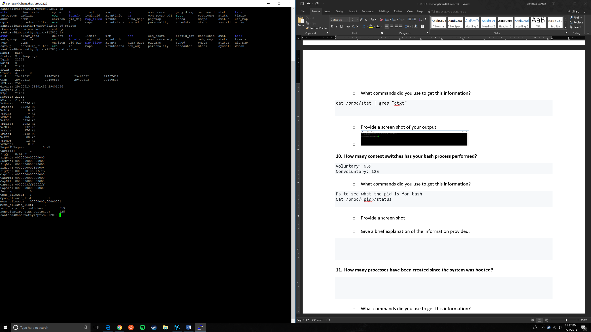Provide a screen shot
  + Give a brief explanation of the information provided.

Gives a bunch of information regarding the process.

1. **How many processes have been created since the system was booted?**

**1304766**

* + What commands did you use to get this information?

Cat /proc/stat

1. **Provide A list of load averages**

load average: 0.18, 0.06, 0.02

* + What commands did you use to get this information?

top

* + Give a brief explanation of load averages.

Average system load over a period of time. It goes by 1 minute, 5 minute, and 15 minutes.

1. **Find the number of disk read requests made on the system for one disk block device**

7 0 loop0 0 0 0 0 0 0 0 0 0 0 0

7 1 loop1 0 0 0 0 0 0 0 0 0 0 0

7 2 loop2 0 0 0 0 0 0 0 0 0 0 0

7 3 loop3 0 0 0 0 0 0 0 0 0 0 0

7 4 loop4 0 0 0 0 0 0 0 0 0 0 0

7 5 loop5 0 0 0 0 0 0 0 0 0 0 0

7 6 loop6 0 0 0 0 0 0 0 0 0 0 0

7 7 loop7 0 0 0 0 0 0 0 0 0 0 0

11 0 sr0 0 0 0 0 0 0 0 0 0 0 0

2 0 fd0 0 0 0 0 0 0 0 0 0 0 0

8 0 sda 7175908 67595 255323438 28186132 4557056 12268983 226927784 14565032 0 26798700 42379488

8 1 sda1 7124356 2206 254325458 27928936 4529822 10549941 212936448 14280196 0 26528612 41847124

8 2 sda2 4938 0 9876 132036 0 0 0 0 0 132032 132032

8 5 sda5 45181 65389 913592 123908 27234 1719042 13991336 284836 0 151772 398868

* + What commands did you use to get this information?

Cat /proc/diskstats

* + Provide a screen shot

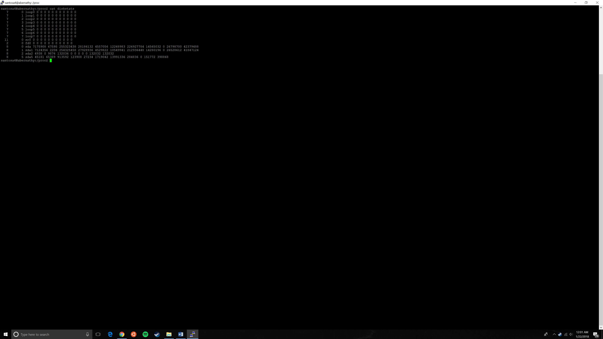

**Part B**

Provide screen shot or cut and paste

Attach your source file separately

